**Codebook**

**GDELT Country Timeline Data**

**Data Request Input Info**

Start Date = 01/01/2011  
End Date = 04/01/2017  
Weighting: NUMARTS  
Must have ALL these keywords: Syrian Refugee  
Must also have AT LEAST ONE of:  
Must NOT have ANY of:

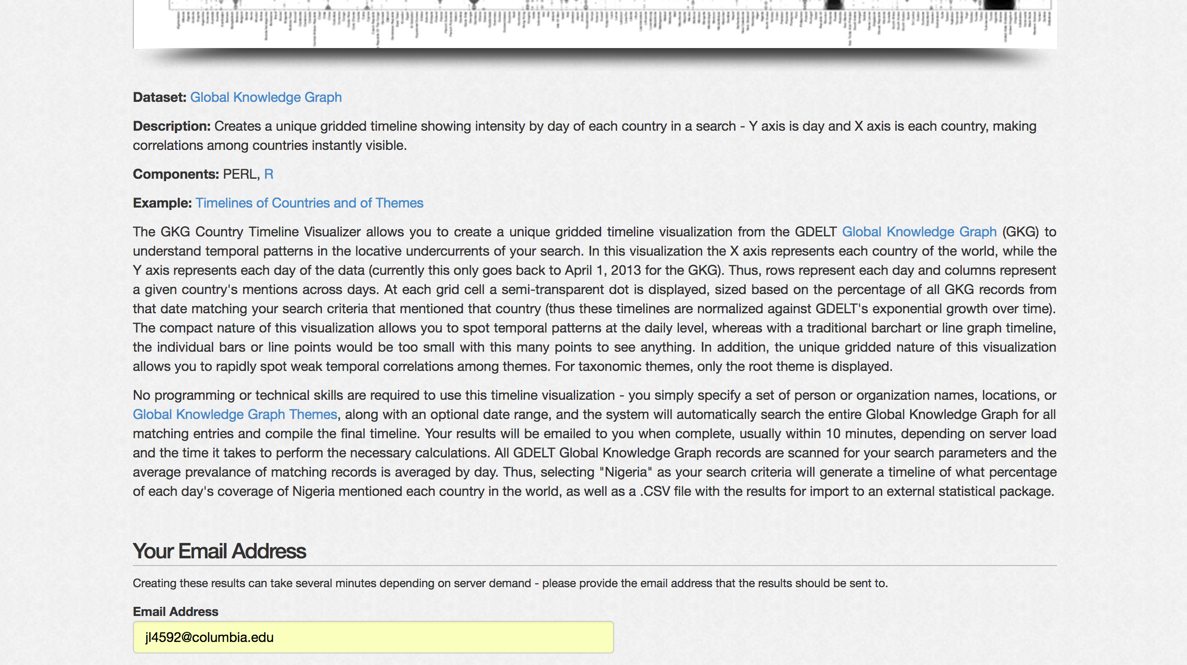

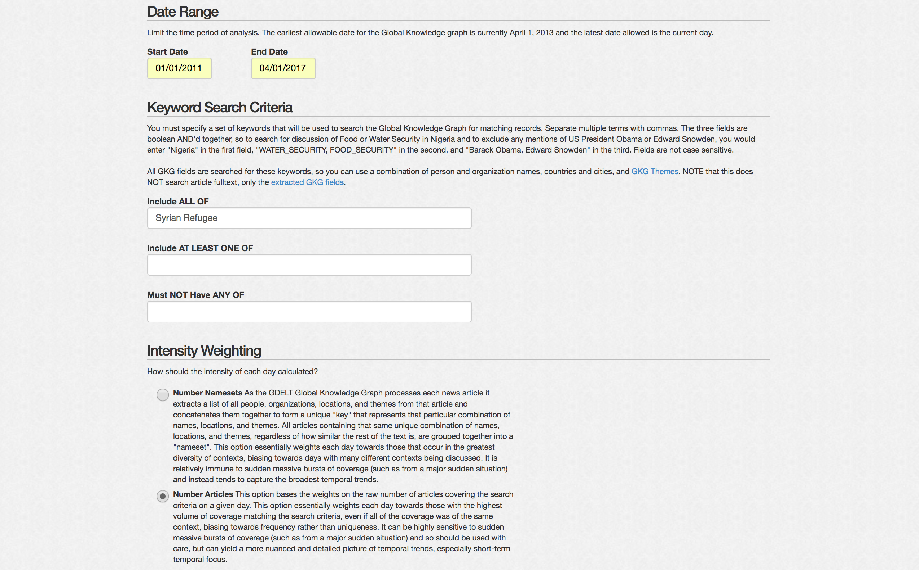

**Output Data Info and Interpretation**

**Dataset:** [Global Knowledge Graph](http://blog.gdeltproject.org/gdelt-global-knowledge-graph/)

**Description:** **Creates a unique gridded timeline showing intensity by day of each country in a search.** Y axis is day and X axis is each country, making correlations among countries instantly visible.

**Example:** [Timelines of Countries and of Themes](http://blog.gdeltproject.org/timelines-of-countries-and-of-themes/)

The GKG Country Timeline Visualizer allows you to create a unique gridded timeline visualization from the GDELT [Global Knowledge Graph](http://blog.gdeltproject.org/gdelt-global-knowledge-graph/) (GKG) to understand temporal patterns in the locative undercurrents of your search. In this visualization, **the X axis represents each country of the world, while the Y axis represents each day of the data (currently this only goes back to April 1, 2013 for the GKG).** Thus, **rows represent each day and columns represent a given country's mentions across days.** At each grid cell a semi-transparent dot is displayed, **sized based on the percentage of all GKG records from that date matching your search criteria that mentioned that country** (thus these timelines are **normalized** against GDELT's exponential growth over time). The compact nature of this visualization allows you to spot temporal patterns at the daily level, whereas with a traditional bar chart or line graph timeline, the individual bars or line points would be too small with this many points to see anything. In addition, the unique gridded nature of this visualization allows you to rapidly spot weak temporal correlations among themes. For taxonomic themes, only the root theme is displayed.

Keyword Search Criteria

You must specify a set of keywords that will be used to search the Global Knowledge Graph (GKG) for matching records. Separate multiple terms with commas. The three fields are Boolean AND'd together, so to search for discussion of Food or Water Security in Nigeria and to exclude any mentions of US President Obama or Edward Snowden, you would enter "Nigeria" in the first field, "WATER_SECURITY, FOOD_SECURITY" in the second, and "Barack Obama, Edward Snowden" in the third. Fields are not case sensitive.

All GDELT Global Knowledge Graph records are scanned for your search parameters and the average prevalence of matching records is averaged by day. Thus, selecting "Nigeria" as your search criteria will generate a timeline of what percentage of each day's coverage of Nigeria mentioned each country in the world, as well as a .CSV file with the results for import to an external statistical package.

**Fields in the Data Set**

**Date: 20130401 – 20170401**

**Countries: 168 countries in total**

**Intensity: Ranges from 0 to 100. (See below for more details.)**

Intensity Weighting

All GKG fields are searched for these keywords, so you can use a combination of person and organization names, countries and cities, and [GKG Themes](http://data.gdeltproject.org/documentation/GDELT-Global_Knowledge_Graph_CategoryList.xlsx). NOTE that this does NOT search article fulltext, only the [extracted GKG fields](http://data.gdeltproject.org/documentation/GDELT-Global_Knowledge_Graph_Codebook.pdf).

The extracted GKG field here is NUMARTS.

NUMARTS (integer): This is the total number of source documents containing one or more mentions of this nameset. This can be used as a method of assessing the “importance” of a nameset: the more discussion of that nameset, the more likely it is to be significant. The total universe of source documents varies over time, so it is recommended that this field be normalized by the average or other measure of the universe of namesets during the time period of interest.

**Number Articles** This option bases the weights on the raw number of articles covering the search criteria on a given day. This option essentially weights each day towards those with the highest volume of coverage matching the search criteria, even if all of the coverage was of the same context, biasing towards frequency rather than uniqueness. It can be highly sensitive to sudden massive bursts of coverage (such as from a major sudden situation) and so should be used with care, but can yield a more nuanced and detailed picture of temporal trends, especially short-term temporal focus.

**Country Timeline Visualizer give you the intensity of NUMARTS: the total number of source documents containing one or more mention of “Syrian Refugee” that day relative to all GKG records from that date matching “Syrian Refugee” that mentioned that country.**

*“Thus, rows represent each day and columns represent a given country's mentions across days. At each grid cell a semi-transparent dot is displayed, sized based on the percentage of all GKG records from that date matching your search criteria that mentioned that country (thus these timelines are normalized against GDELT's exponential growth over time).”*

Exploratory Analysis

(some visualization done on Tableau)

